## **US Census Demographic Data**

Insight 1

Link

<https://public.tableau.com/views/Incomeperstate2015vs2017/Incomeperstate2015vs2017?:language=en-US&publish=yes&:display_count=n&:origin=viz_share_link>

Comparing 2015 Vs 2017 Income per state where California in both the highest one, 2nd Texas and 3rd Florida.

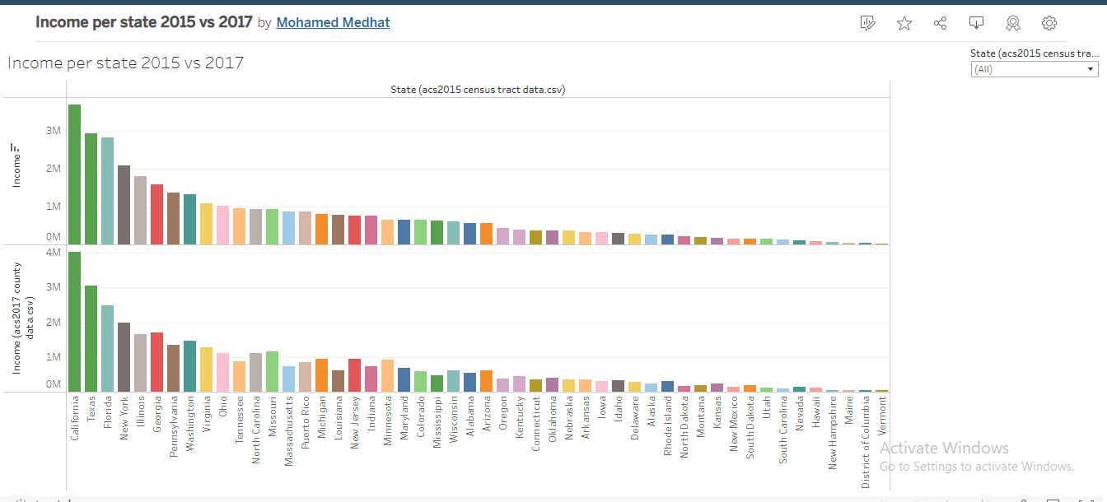

Insight 2

Link

<https://public.tableau.com/views/2015PoputioncitizanUnemployment/2015PoputioncitizanUnemployment?:language=en-US&publish=yes&:display_count=n&:origin=viz_share_link>

Comparing population, number of citizens and unemployment. California is the highest one in all, however after that some variant happens and unemployment isn’t always direct relationship with population

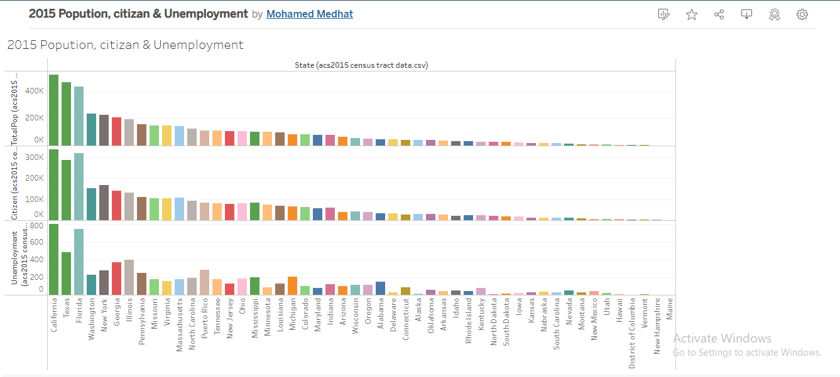

Insight 3

<https://public.tableau.com/views/RelationbetweenwhiteblackandAsiancount/Sheet3?:language=en-US&publish=yes&:display_count=n&:origin=viz_share_link>

White people are the demonent in all states, some states have black people more, Asians are more in Texas and New york.

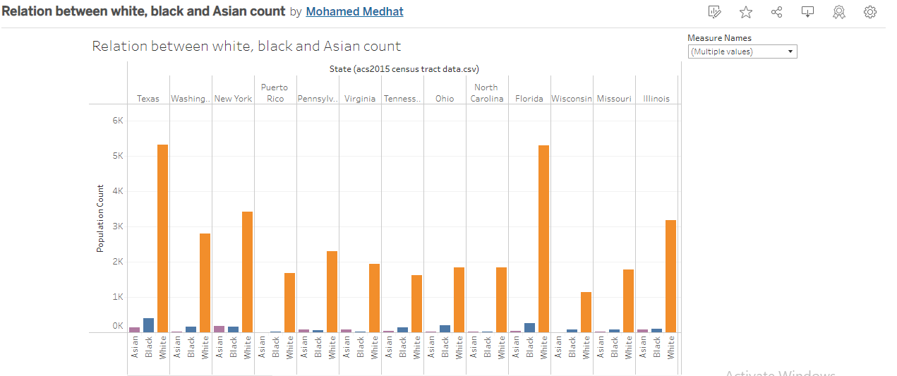

Insight 4

<https://public.tableau.com/views/MenVsWomen_16498543269500/MenVsWomencount?:language=en-US&publish=yes&:display_count=n&:origin=viz_share_link>

A different way of presenting where men are Size of circle and Women are the colored part, they are almost directly related.

